PROJECT DEMONSTRATION

1. Employee Dataset Creation
In the first step of the project, an employee dataset is created using a spreadsheet application such as Google Sheets or Microsoft Excel. The dataset contains important employee details such as name, email, department, manager, and phone number. Each row in the spreadsheet represents a different employee record.
The dataset is prepared carefully to ensure that all required fields are included. After entering the sample employee data, the file is downloaded in a compatible format such as CSV or Excel (.xlsx). This dataset will later be imported into the ServiceNow platform using the Import Sets feature.
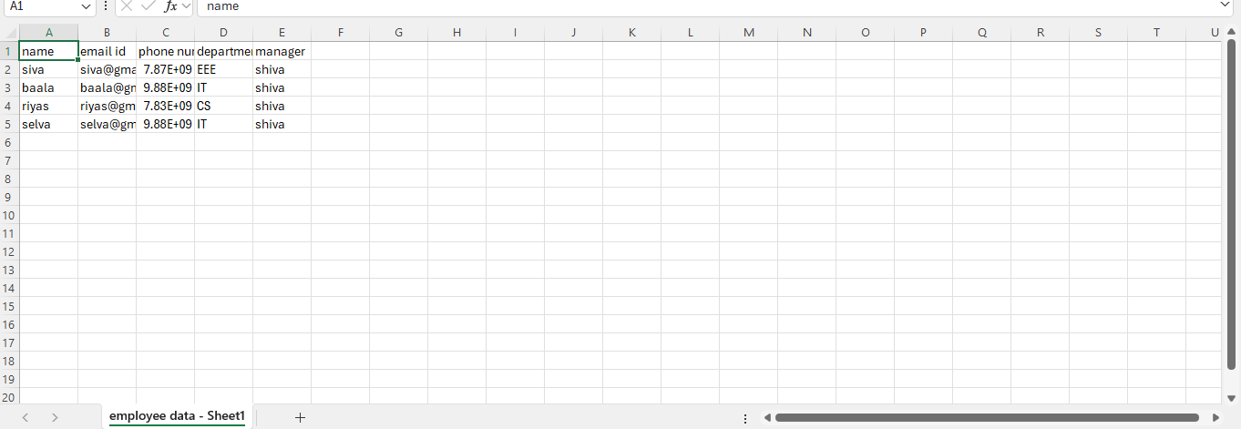

2. Loading Data into ServiceNow
The prepared employee dataset is uploaded into the ServiceNow platform using the Load Data option under the System Import Sets module. During this process, the file is selected and uploaded to create an Import Set Table.
The Import Set Table acts as a temporary staging area where the uploaded data is stored before being transferred to the target table. Once the file is uploaded successfully, the system reads the dataset and displays the imported records

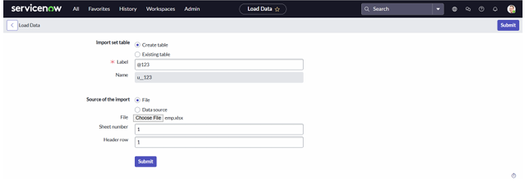

3. Creating Transform Map
After the data is loaded into the Import Set Table, a Transform Map is created to define how the data should be transferred to the target table. In this project, the target table is the User table (sys_user).
The transform map connects the source table (Import Set Table) and the target table (User Table). This configuration ensures that the imported employee data is placed into the correct fields in the system.
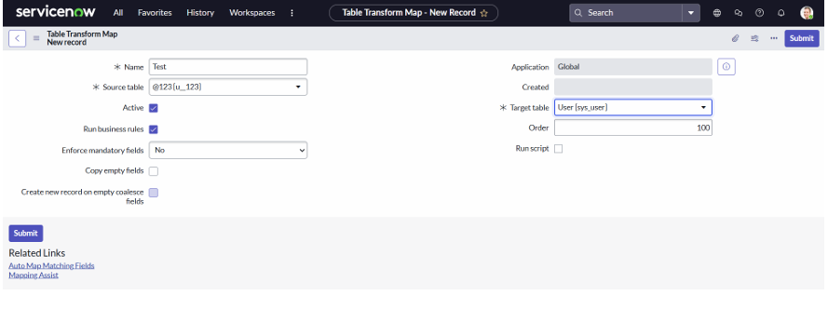

4. Field Mapping
The next step in the demonstration involves mapping the fields between the source table and the target table. ServiceNow provides an Auto Map Matching Fields option that automatically matches fields with similar names.
Some fields such as manager may require manual mapping using the Mapping Assist feature. This step ensures that each field from the dataset is correctly mapped to the appropriate field in the user table.
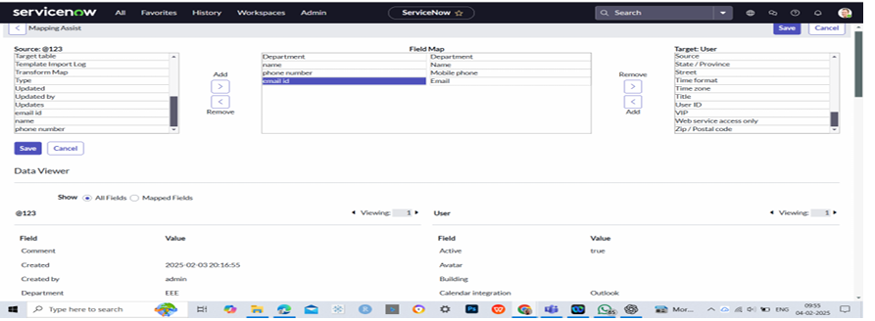

5. Transforming the Data
Once the field mapping process is completed, the Transform option is used to move the data from the Import Set Table to the User Table.
During this process, the system reads each record in the import table and inserts the mapped data into the user table. After the transformation is completed, the system displays a message confirming that the records have been inserted successfully.

6. Configuring Dot Walking
To retrieve related information automatically, the incident form layout is customized using dot walking. Fields such as Assigned To.Department, Assigned To.Email, and Assigned To.Manager are added to the incident form.
These fields retrieve information from the user table through the Assigned To reference field. This configuration allows the system to display employee details automatically when assigning incidents.
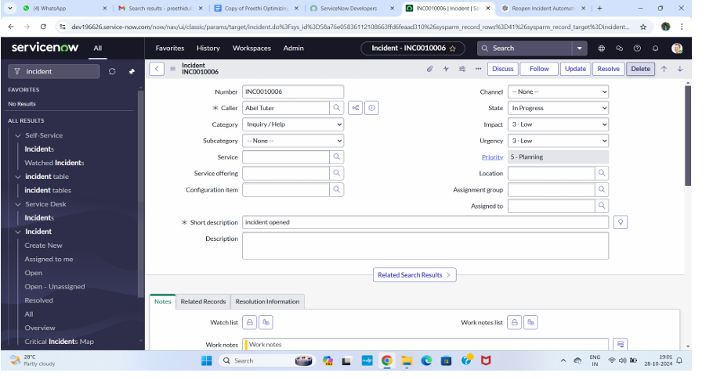

7. Demonstration of Final Output
In the final step of the demonstration, a new incident record is created. The required fields are filled, and an employee from the imported records is selected in the Assigned To field.
Once the employee is selected, the system automatically displays the department, email, and manager information using dot walking.
This confirms that the system successfully retrieves related information and displays it on the incident form
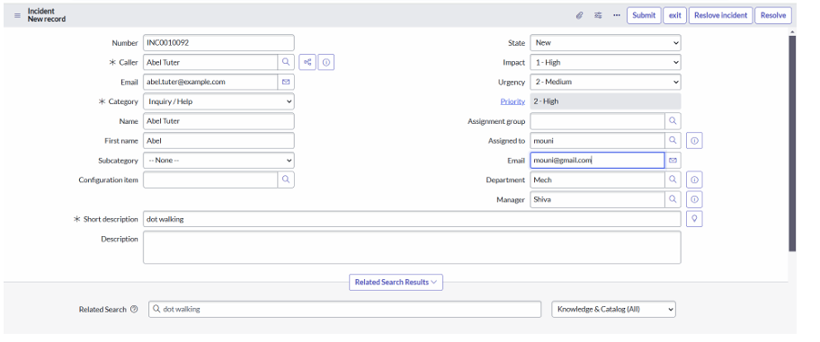

8. Summary of Demonstration
The project demonstration successfully shows the process of importing employee data and retrieving related information using dot walking in ServiceNow. The screenshots included in the documentation help illustrate each step of the implementation process.
The demonstration confirms that the system works correctly and achieves the objective of automating employee data import and displaying related information in the incident management module.

